Name- varada bhide
PRN-B25CE1074
div-CE2
TUT-5

Book finding

RESEARCH

A library is a collection of resources—including books, periodicals, digital media, and more—that is organized for use and access by a defined community. Libraries can be physical spaces, virtual spaces, or both, and they provide access to materials for reading, study, and research, often with services like borrowing and information assistance.
Libraries are important because they provide free access to information and resources, act as community hubs, support education and literacy, and help bridge the digital divide. They serve as safe spaces for learning and community events, offer resources for job seekers, and preserve cultural and historical materials.
Education and literacy

- Promote reading: Libraries encourage a love of reading and learning from an early age through story times and access to books for all ages.
- Support academic success: They provide resources and quiet spaces for students to study, research, and complete homework.
- Develop critical skills: Librarians help people develop information literacy, teaching them how to find, evaluate, and use information effectively and ethically.

ANALYSIS

Libraries provide a wide range of services including access to books and other media, community programs, and assistance with research and technology. They serve as community hubs that support education, literacy, and lifelong learning for people of all ages, backgrounds, and income levels.
Books are then arranged on shelves according to these call numbers to keep related topics together, allowing for browsing. Within each subject, the books are further sorted by author's last name.
The concept behind borrowing a book from a library is to provide free and temporary access to information and entertainment for community members, promoting literacy, education, and a shared resource model. It's a system of resource sharing where one person can use a book for a limited time before returning it for someone else to borrow, reducing the individual need to purchase every book.

IDEATE

Libraries store book information online using an Integrated Library System (ILS), a software that catalogs the entire collection. They sort books by assigning a unique call number based on a classification system like the Dewey Decimal Classification. This call number is put on the book's spine and in the online database, allowing for both physical sorting on shelves and digital sorting in the catalog.
This helps in accessing the required book easily.

BUILD

// Online C compiler to run C program online
#include <stdio.h>
#include<string.h>

int main()
{
int i,j;

char name[10][50]={"To kill a mockingbird","animal farm","lord of the rings","balbharti english","the alchemist","batatyachi chal","panipat","shyamchi aai","the jungle book","yayati"};
int price[10]={378,222,472,155,230,200,412,148,299,337};
char inputname[20];
int found=0;
printf("Enter name of the book-");
scanf("%s",inputname);

for(i=0;i<10;i++)
{

if(strcmp(inputname,name[i])==0)
{
printf("Name- %s\n",name[i]);
printf("Price- %d\n",price[i]);
found++;
break;
}
}
if(found==0)
{
printf("Book not found");
}

return 0;
}

TEST
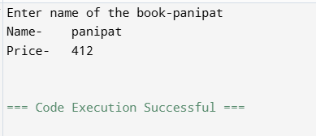
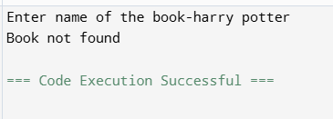

IMPLEMENT

https://github.com/varadabhide/Book-Finding

CONCLUSION

The organization of library books is crucial for fulfilling a library's purpose of connecting users with information efficiently and effectively. A well-organized system saves user time, enhances the library's aesthetics and user experience, and allows for the preservation of the collection

LINKS
https://en.wikipedia.org/wiki/Library
https://nios.ac.in/media/documents/SrSecLibrary/LCh-009.pdf

